TIME SLOT MANAGEMENT (ZFM) FROM THE PERSPECTIVE OF THE LOGISTICS SERVICE PROVIDERS
An empirical study on the effectiveness and acceptance of time slot management systems in practice

Foreword
For the first time, CARGOCLIX surveyed transport and logistics service providers about the effectiveness of time slot management systems. A total of 622 companies have participated.

"Waiting times at the ramp". The topic has been high on the agenda for years in industry, trade and services. Reports are written, sworn transparency among stakeholders, yet it indicates the cause no doubt: As long as carriers can deliver unplanned any time, the congestion on the ramp is connected to long queues at peak times and several hours of waiting times inevitable.

The conclusion of all known studies can be summed up in a simple formula: good and flexible time slot management increases ramp efficiency for ramp operators and logistics service providers alike. It improves freight operations and enables more efficient use of the infrastructure. Last but not least, punctual handling at the loading ramp helps to improve working conditions. The satisfaction of the ramp operators with time slot management systems, in particular with regard to a higher transparency of the processes in the incoming and outgoing goods and thus a higher economic efficiency, now prove numerous practical examples.

Nevertheless, the discussion about the benefits of time slot management systems is particularly controversial among freight carriers. According to the study of the Federal Ministry of Transport "Interface ramp - solutions to avoid waiting times" from the year 2013, the ramp operators give the instrument time slot management a higher contribution to the tense situation on the ramp, as the logistics service providers. According to this, 59.8 percent of shippers, and still 44.8 percent of carriers, certify that the systems are making a high and very high contribution to solving the problems on the ramp. In contrast, only 35.7 percent of the transport and logistics service providers in time slot management systems see a high and very high contribution to shortening waiting times or bureaucratic effort on the ramp. Transport and logistics service providers are therefore rather critical of the introduction of time slot management systems.

For the first time, CARGOCLIX commissioned a survey of logistics service providers as users for the effectiveness of time slot management systems.
A total of 622 logistics service providers answered the questionnaire on changes and improvements on the ramp after the introduction of time slot management systems. This makes the study one of the largest of its kind.

Taking into consideration the critical attitude of the target group, the results are both surprising and pleasing. The high acceptance values indicate that approval for time slot management has increased among logistics service providers. This may also be due to the fact that the increasing number of deliveries and pickups without time slot management systems would be difficult to cope with. At the same time, however, Timeslot management Systems have evolved significantly and are now adapting to individual requirements thanks to new dynamic functions "like a tailor-made suit".

As a need for action number 1, the present study also shows that ramp operators have room for improvement, especially with regard to the observance of time windows and the communication of success through the use of time slot management. As a leading provider of time slot management systems, we are pleased to provide this study with a comprehensive analysis of the effectiveness and acceptance of time slot management systems in practice.

- Management Summary
Lack of efficiency at Germany's ramps is associated with high costs for all involved. The pressure to act is correspondingly high and there is widespread consensus that the introduction of time slot management systems (ZFMs) has no alternative in order to improve efficiency at the ramps. In hardly any other area of logistics, the use of information technologies can quickly bring about positive effects. It is therefore not surprising that, from the point of view of logistics service providers, time slot management systems, in particular, significantly reduce waiting times at the ramp.

With the present study *), CARGOCLIX has for the first time deliberately asked transport and logistics service providers about the effectiveness of time slot management systems. A total of 622 logistics service providers and carriers responded to the questionnaire on the changes and improvements on the ramp after the introduction of time slot management systems. This makes the study one of the largest of its kind.

Requirements of logistics service providers for time slot management systems
The expectations of logistics service providers for the use of time slot management systems are high. Users consider the following aspects to be important and very important:
• Faster loading and unloading at the ramps (94.3 percent)
• Reduction of waiting times (93.8 percent)
• Easy booking process (92.5 percent)
• Less bureaucracy (90.2 percent)
• Better processes with higher transparency (88.9 percent)
• Better communication (87.2 percent).

These points represent the main benefit of time slot management systems for logistics service providers and, in turn, are the critical factors for acceptance and use of the systems for ramp operators.

On the other hand, time slot management is neither a panacea for solving the current problems on the ramp, nor can all problems be solved at once. But the systems can make a significant contribution to significantly improving the situation. The results of the 622 participants in the present study clearly confirm this.

Effectiveness and acceptance of time slot management systems
Key findings of the study include:
- 58 percent of participants in the survey on the effectiveness and acceptance of Timeslot management Systems - more than one in two of them - found that using time slot management systems reduces waiting times.
- 48 percent of the respondents said that the bureaucratic workload had been reduced by using a time slot management system at the ramp.

Particularly interesting are the evaluations of how much time or effort the logistics service providers can actually save on the ramp through time slot management. For the first time, reliable figures are available as part of the survey:

- The 359 participants who noticed a reduction (58 percent) were asked to estimate the amount of time saved: 18 percent stated that waiting times had at least halved or even ceased to occur. 34 per cent observe a reduction between 26 and 50 per cent and 39 per cent of still up to 25 per cent. 9 percent cannot give any information on this.

- Assuming an average waiting time at the ramp of 68 minutes (source: SCI Logistikbarometer, 15 June 2011, arithmetical mean), this means for every fifth of those who have confirmed shorter waiting times an average reduction of over 34 minutes, every third waits between 17 and 34 minutes less and another third still up to 17 minutes less. Assuming imputed costs of around EUR 50 per hour for drivers and trucks, the monetary advantage of time slot management for one fifth of the above-mentioned group of logistics service providers is at least EUR 28.33 per ramp contact, and between EUR 14.17 and EUR 28.33 for one third. If the calculation also takes into account those companies (42 percent) that have not noticed any improvement in waiting times, the result is still an average reduction of 13 minutes or the equivalent of EUR 10.79.

- A medium-sized logistics service provider with 10,000 ramp stops could thus save almost 110,000 EUR per year through time slot management, a logistics group with 300,000 stops around 3.2 million EUR.

- The 299 participants who saw a reduction in bureaucracy (48 percent) were asked to estimate the scale: for 39 percent, bureaucracy costs are reduced by up to 25 percent, 33 percent between 26 and 50 percent, and 17 percent between 51 and 75 percent and for three percent between 76 and 100 percent.

The majority of the transport and logistics service providers are also seeing an improvement in other areas.

- 51 percent state that the time required for loading and unloading has become shorter, 25 percent of it even much shorter.

- The transparency of the information has improved for 53 percent of the respondents, for every fifth (19 percent) even significantly.

- When it comes to process optimization, respondents who see an improvement (46 percent) are in the balance with those who do not observe any change (48 percent).

- Almost one in three respondents (30 percent) states that the introduction of time slot management systems also improves the tone of conversation on the ramp.

In conclusion, the present results underline the effectiveness of time slot management systems. This is true as transport and logistics service providers are a particularly critical user group.

Potential for Improvement in the Use of Time Slot Management Systems

But, the fact is that the benefits of Time Slot Management often, systems do not arrive in the same way as hauliers perceive them. Naturally, ramp operators benefit from significantly higher process improvements and therefore assess the benefits of time slot management almost consistently more positively than the delivering or picking service providers, as has been repeatedly stated in studies.

Reason for the restraint of logistics service providers are several factors:

- Logistics service providers and carriers do not have the choice of which time slot management is used. They are bound to the systems of ramp operators and not only have to settle for several different systems, but also, for example, for systems that are perceived as being overpriced or even technically faulty. In addition, often soft factors, such as the tone on the ramp, too few bookable time windows or too short or too many assigned time windows superimpose the positive effects.

- One of the reasons for the industry's critical attitude may be that booked time slots are often not adhered to by the ramp operator because the time slot length is either too short or too few personnel are available, or that even trucks owned by the trade are brought forward without time slots. Numerous responses of the interviewees support this thesis. Service providers report that this not only results in long waiting times, but also that freight forwarders are repeatedly turned away at the end of the ramps, especially at the commercial ramps. In all cases, this is perceived as a bad performance and negatively influences the image of time slot management.

The present study also shows, however, that commercial ramps are better than their reputation. For example, those logistics service providers and freight forwarders who predominantly (more than 75 percent each) use commercial or industrial ramps rate the effectiveness of time slot management systems on the ramps as similarly positive.

Success and acceptance critical: the booking price

A good organized ramp is commonly seen as a contributing factor to ramp operators. Nevertheless, the users accept a price of up to one euro. This is especially true when the benefits of the ramp are actually felt through better organization, less waiting time or less bureaucracy.

For this reason, the price that a logistics service provider has to pay for a time window plays a crucial role for the acceptance of time slot management for psychological reasons. The results of the study clearly support this.
- With almost 72 percent, the majority of respondents consider a price of up to € 0.50 acceptable for booking a time slot.

- Around 23 percent of those surveyed would also accept a price of between 0.51 and 1.00 euros as their upper limit.

- Costs of over 1.00 euros, however, are seen extremely critical: a price between 1.01 and 2 euros approve only four percent of logistics service providers, over 2.00 euros even only 0.2 percent.

- With increasing number of locations and turnover of the logistics service provider, willingness to pay is also falling.

Opportunities and Potentials of Time Slot Management

No one would argue today that time slot management systems are self-fulfilling. Ramp operators are required to turn the company's screws to make a time slot management system a success for everyone. The greatest potential arises after analyzing the data in the following areas:

- Shorter waiting times and less bureaucracy are only possible by analyzing and optimizing the entire supply chain. Time slot management systems can support this process, but can not solve it on its own. No time slot management system can improve inefficient processes, compensate for limited capacities, such as loading and unloading, or compensate for a lack of ramps and personnel.
- The best time slot management system is of no use if it is undermined at the ramp. Target conflicts can be solved by open communication. It is important that logistics service providers immediately perceive the positive effects of a time slot management system. Suitable measures are flyers, workshops and a regular monitoring with communication of the improvements achieved for both sides.

The ramp operator should "get the logistics service provider on board". Companies that work with information sheets and personal customer advice to persuade the logistics service providers and repeatedly actively promote the booking of time slots are more successful.

Conclusion

It remains to be noted that the proverbial "fight on the ramp" is noticeably eased by the introduction of time slot management. The goal must continue to be that as many companies as possible - whether ramp operators or logistics service providers - use time slot management and develop their processes in the sense of an optimal overall system. This concerns in particular the inclusion of the interests of logistics service providers and carriers.

Time slot management systems, which are designed exclusively for maximizing the benefits of the ramp operator, run the risk of losing their optimization gains due to the lack of acceptance by the logistics service providers.

Incidentally, the developers of time slot management continuously contribute to improving the overall situation: With the increasing flexibility of time slot management systems through the integration of new functions, such as dynamic booking masks and time window lengths, variable limits and the upload of freight documents, bookings are already easier and the ramp handling has become more individualized.

2. Information about the Study

This online survey on the effectiveness of time slot management systems was exclusively aimed at transport and logistics service providers. It is one of the largest of its kind.

The present online survey has asked in a previously unavailable range how the situation at the ramp has changed due to the introduction of time slot management systems and how these changes are evaluated.

The survey was exclusively for logistics service providers and carriers. The high number of participants gives a representative picture of the market situation.

The following information was collected:

• Have waiting times through the use of time slot management systems reduced - and if so, how much?
• Has the bureaucratic burden of using time slot management systems been reduced - and if so, how much?
• What further changes have resulted from the introduction of a time slot management system and how are these evaluated?
• Which booking price is considered acceptable by the logistics service providers?

Client of the investigation
Cargoclix
Dr. Meier & Schmidt, Freiburg i.Br.

- Changes through the introduction of time slot management systems

Logistics service providers will notice shorter waiting and loading and unloading times, less bureaucracy, more transparency and even better handling at the ramps. For carriers and freight forwarding companies as users of time slot management systems, the key benefit is the reduction of waiting times (3.1) and the reduction of bureaucracy (3.2.). These parameters decisively determine the acceptance of time slot management systems in transport and logistics service providers. In addition, there are numerous additional factors that benefit transport and forwarding companies (3.3.) And that also increases acceptance.

3.1. Waiting times

Waiting times are one of the biggest nuisances on the ramp for transport and logistics service providers. When the truck arrives punctually, the waiting period is defined as the period from the beginning of the agreed time window until the start of the handling of the truck.

Question: Have waiting times been reduced through the use of time slot management systems - and if so, how much?

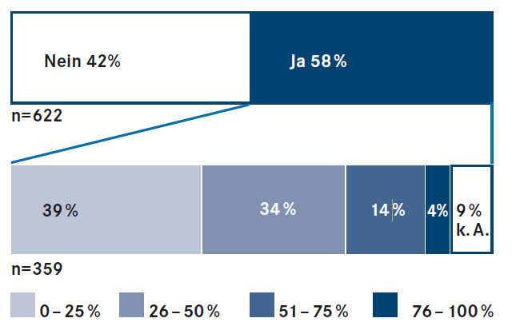
58 percent of logistics service providers note that the waiting times are being cut by using Timeslot Management systems. In view of the fact that the logistics service providers are a target group that is critical of ZFM, this vote impressively confirms the effectiveness of ZFM
Key messages and interpretation

Reducing waiting time is one of the key benefits of time slot management systems for logistics service providers. 93.8 percent of respondents consider this to be important and very important. Conversely, a shorter waiting time for ramp operators is a critical factor for the acceptance and use of the systems.

58 percent of logistics service providers note a reduction in waiting times through the use of time slot management systems. At 42 percent this is not true. Given the fact that the logistics service providers are facing a reduction of between 26 and 50 percent and 39 percent a reduction in waiting times of up to 25 percent. 9 percent did not provide any information.

Assuming an average waiting time at the ramp (Source: SCI Logistics Barometer, June 15, 2011, arithmetic mean) of 68 minutes, for every fifth of those who have confirmed shorter waiting times, this means an average reduction of over 34 minutes, one in three waiting between 17 and 34 minutes less and another third still up to 17 minutes less. Assuming further imputed costs of around EUR 50 per hour for driver and truck, the monetary advantage of time slot management for one fifth of the above-mentioned group of logistics service providers is at least EUR 28.33 per ramp contact, for each third between EUR 14.17 and 28.33 EUR. Taking into account in the calculation also those companies (42 percent), which have not found any improvement in the waiting time, so there is arithmetically still an average reduction of 13 minutes or the equivalent of 10.79 EUR.

However, the fact is that the benefits of time slot management systems often do not materialize in the way carriers are perceived by the ramp operators. This is due to several factors:

Logistics service providers and carriers do not have the choice of which system to use. They are bound to the ramp operators and thus not only have to settle for different providers, but also, for example, for systems that are perceived as being overpriced or technically defective. In addition, often soft factors such as the tone of conversation at the ramp, too few bookable and too short time windows or inflexible booking options superimpose the perception of the positive effects.

The present study also shows: ramp is not equal to ramp and time slot management is not equal to time slot management. Staff shortages and structural problems can overshadow the effectiveness of the systems. However, satisfaction will increase only if ramp operators not only oblige logistic service providers to use their systems, but also dimension sufficient time slots and ramp capacities and make them flexible so that time slots can be reliably met. Case studies with ramp operators repeatedly show that the greater the acceptance of the systems, the more the ramp operator promotes them and thus gets the service providers "on board". Companies that use information sheets or personal advice, for example, and who actively advertise time windows, are more successful.

  - Bureaucratic effort

The bureaucracy is a big challenge on the ramp. The term refers to the time required for communication and coordination between the parties in the context of a delivery.

Question: Has the bureaucracy reduced by the use of time slot management systems - and if so, how much?

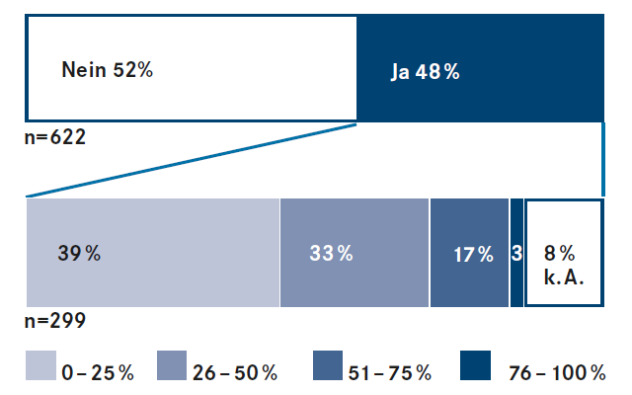
48 percent of respondents - just under half - explain that the bureaucracy on the ramp decreases when using a ZFM system. Of this, the bureaucratic effort for 39 percent is reduced by up to 25 percent, 33 percent between 26 and 50 percent, 17 percent between 51 and 75 percent and for three percent between 76 and 100 percent.

Key messages and interpretation

90.2 percent of logistics service providers consider less bureaucracy through time slot management as an important or very important goal in the context of this investigation.

48 percent of respondents - just under half - explain that the bureaucracy on the ramp decreases when using a time slot management system. That's not the case for 52 percent. Possibly, the latter group increasingly drives ramps with a heterogeneous commodity structure, where the bureaucratic effort is inherently higher.

The 299 participants who saw a reduction in bureaucracy (48 percent) were asked to estimate the scale: for 39 percent, bureaucracy costs are reduced by up to 25 percent, 33 percent between 26 and 50 percent, and 17 percent between 51 and 75 percent and for 3 percent between 76 and 100 percent. 8 percent cannot give any information.

  - Loading and unloading, processes, transparency, handling tone

In addition to the reduction of waiting times and bureaucratic effort, further parameters for the effectiveness of time slot management systems have been queried in the present study:

Loading and unloading time this is understood to mean the time from the actual beginning of the handling to its end. For 94.3 percent of logistics service providers, faster loading and unloading through time slot management is important or very important.

- Loading and unloading time
This is understood as the time from the actual beginning of the processing until the end of it. For 94.3 percent of logistics service providers, faster loading and unloading through time slot management is important or very important.

- Runs on the ramp
These include various (infra) structural and personnel problems of insufficient parking and storage areas to the lack of use of ramp staff, among others leads to the cooperation of the driver during unloading. For 88.9 percent of logistics service providers, an improvement in the processes of time slot management is important or very important.

- Transparency of information
This is about the lack of information flow between all parties involved in all processes at the ramp. For 88.9 percent of logistics service providers, improving transparency through time slot management is important or very important.

- Dating tone at the ramp
The tone of conversation on the ramp belongs to the "soft" or "social" factors. The above-mentioned problems and the time constraints faced by ramp operators and logistics service providers alike are considered to be a cause of rough handling.

Question: What other changes - beyond shortening the waiting time and reducing bureaucracy - have emerged since the introduction of a time slot management system?

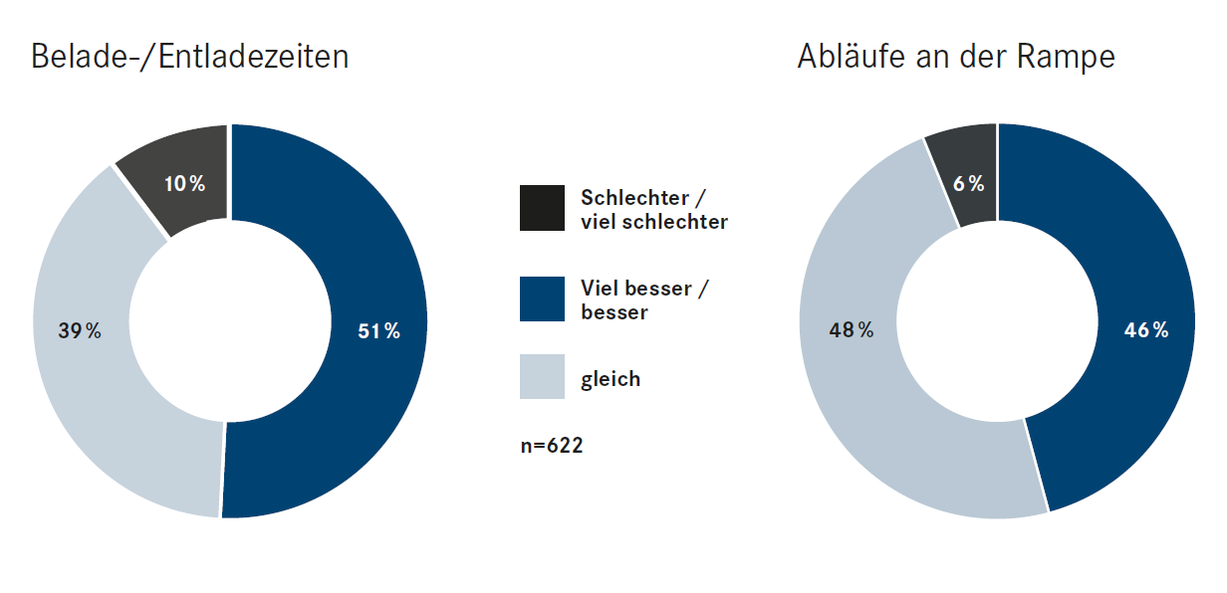

51 percent of respondents perceive an improvement in loading and unloading times by ZFM, every fifth even clear. The processes on the ramp itself still have room for improvement: respondents who see an improvement (46 percent) and those who do not observe any change (48 percent) hold the balance.

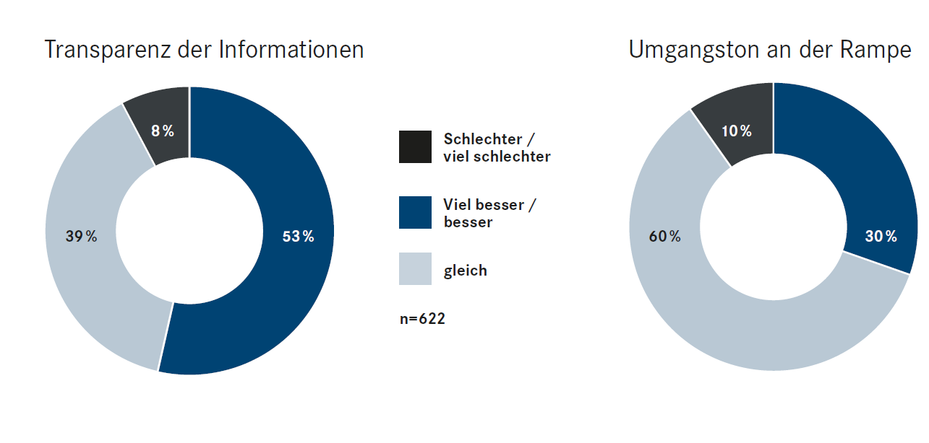
The transparency of the information on the processes at the ramp has improved for 53 percent of respondents, for every fifth (19 percent) of them even significantly. For 30 percent of respondents, Time Slot Management even improved the tone.

Key messages and interpretation

The majority of respondents (51 percent) perceive an improvement in the time needed for loading and unloading. One in four (25 percent) even says that loading and unloading times have improved significantly. The transparency of the information on the processes at the ramp has improved for 53 percent of respondents, for every fifth (19 percent) of them even significantly.

The processes on the ramp itself, however, are still a cause for criticism: Here, the respondents who see an improvement (46 percent), with those who observe no change (48 percent), the balance. In fact, with the introduction of time slot management systems, no structural or personnel issues that are relevant to this issue can be solved.

Almost one in three respondents (30 percent) has the impression that the introduction of time slot management systems improves the tone on the ramp. This is an indication that both the saving of time (in this case: waiting and loading and unloading times) and the reduction of stress (in this case: transparency of information) result in a partnership-based cooperation on the ramp. Further relaxation results from the fact that ramp operators can better plan capacity and staffing requirements.

Within the scope of the investigation, the satisfaction of the transport and logistics service providers with time slot management systems has also been converted into grades.
On a satisfaction scale of 1 (best) to 5 (lowest), the transparency of the information with the top grade of 2.47 scores the best. It is precisely this transparency that lays the foundation for organized ramps. The loading and unloading times are 2.5 points and the ramps are 2.54. The tone of contact at the ramp is a bit off at the grade 2.78. As always, a rough wind is blowing on the ramp and thus there is still a promising potential for improvement.

For example, the availability and lack of equipment of social rooms for the drivers provide grounds for criticism on the part of the logistics service providers.

- Pricing

The booking price for a time window plays an important role in the acceptance of time slot management systems in practice.

Depending on the time slot management system, the prices per loading and unloading slot today are between 50 cents and 2.50 euros, sometimes even higher. The amount includes all booking transactions, data transfers and free support for industry, commerce, freight forwarders and carriers.

Question: Which price per slot in Euro do you consider acceptable?

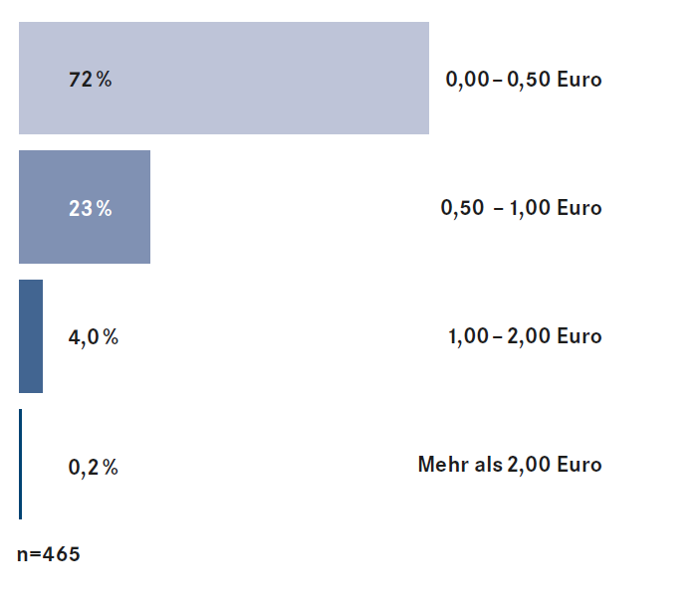

With almost 72 percent, the majority of respondents consider a price of up to € 0.50 acceptable for booking a time slot. About 23 percent also consider a price between 0.51 to 1.00 euros justified. Prices over one euro are viewed very critically.

Key messages and interpretation

With almost 72 percent, the majority of respondents consider a price of up to € 0.50 acceptable for booking a time slot.

Around 23 percent of those surveyed would also accept a price of between 0.51 and 1.00 euros as their upper limit.

Costs of more than 1.00 euros, however, are seen critically: A price between 1.01 and 2 euros approve only four percent of logistics service providers, over 2.00 euros even only 0.2 percent.

With increasing number of locations and turnover of the logistics service provider, willingness to pay is also falling.

A well-organized ramp is commonly seen as a contributing factor to ramp operators. Nevertheless, the users accept a price of up to one euro. This is especially true when the benefits of the ramp are actually felt through better organization, less waiting time or less bureaucracy.

However, since the logistics service providers do not have the free choice of the system, the pricing is not fully subject to the laws of the market. It can be assumed that excessive booking prices of significantly more than 1.00 euros from a psychological point of view contribute significantly to the critical attitude of service providers towards the topic of time slot management. In particular, the ramps of the trade are in this regard again and again in the criticism.

Plain text

"TimeSlot enables us today to provide a professional cross-company process planning with our carriers at a very reasonable price. The workload is constant and the ramp planning has noticeably relaxed. "
Andre Tenbruen, Warehouse Manager Germany at HAVI Logistics.

"TimeSlot was installed and live in two weeks. Since then, the traffic jam has become history, the process is much easier and the personnel planning is better. "
Andreas Karl, Head of Warehouse Logistics at the Austrian Donaulager GmbH, Linz.

"Our main goal was to get transparency about the processes in the incoming goods department. We have achieved that in a short time. "
Werner Böhm, Head of Transport Logistics & Production Supply Logistics at the Mercedes-Benz Berlin plant.

"At the Heimstetten site we had a supplier who immediately booked time windows right from the start and also incorporated them very well in his tour planning. He passed the queue of non-bookers punctually at 7 o'clock in the morning and was unloaded immediately. You cannot show the benefits of time slot management any better. "
Maike Lehnart, standard and excellence logistics at Papyrus.

"When you consider how much money a stationary truck costs, the use of such an application pays off, which is a win-win situation for all concerned" (...) "Ultimately
we, our customers, anyone in the chain, have to pay for the waiting time - so if we manage to streamline that chain, then everyone benefits."
Thomas König, responsible for logistics at Agravis Raiffeisen AG.

Impressum
CARGOCLIX
Dr. Meier & Schmidt GmbH
Münsterplatz 11 / im Kornhaus
D-79098 Freiburg i.Br.
Internet: www.cargoclix.com

Konzeption und Redaktion:
wuermser.communications
Postfach 1304
D-85767 Unterföhring
Internet: www.wuermser.com

Rückfragen zur Studie:
Dr. Victor Meier
meier@cargoclix.com

Anita Würmser
Telefon: 089 / 95 82 26 -11
anita.wuermser@wuermser.com
Copyright by
CARGOCLIX Dr. Meier & Schmidt GmbH, Freiburg i.Br.,
im Februar 2016

